Example #1:
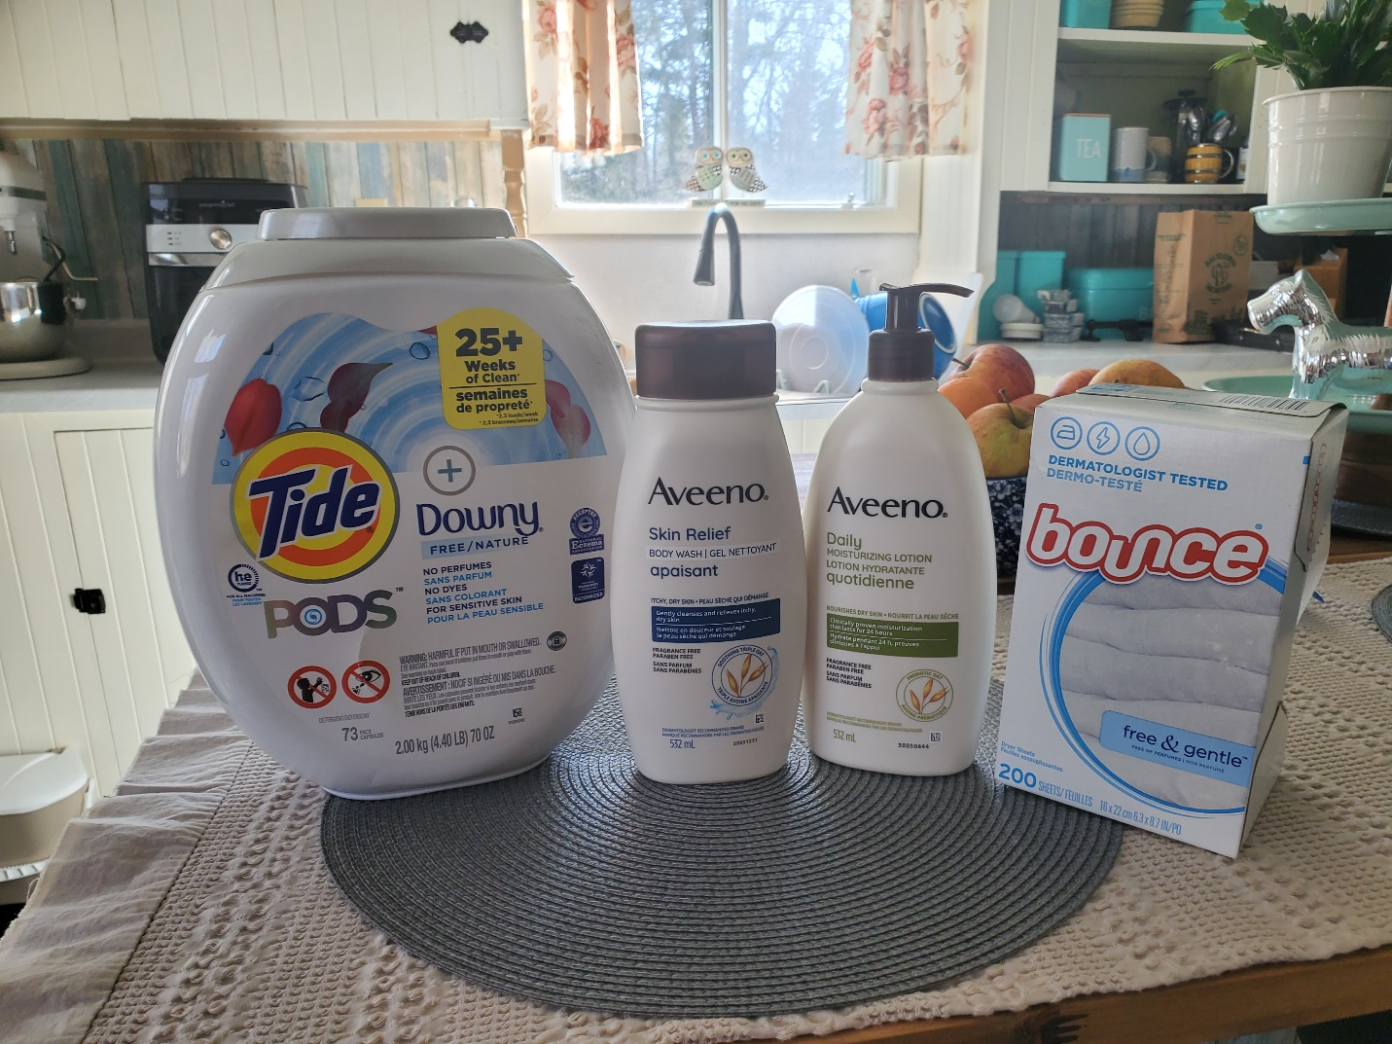

Accompanying Text: I have Environmental Sensitivities that cause real harm, like migraines and nausea, when people around me use scented products. When people choose to go scent-free, I feel safe going to work and other places in the community.
ID: A collection of four scent free products including laundry detergent, body wash, lotion, and dryer sheets.
Alt Text: A collection of scent free laundry and personal care products.

Example #2:
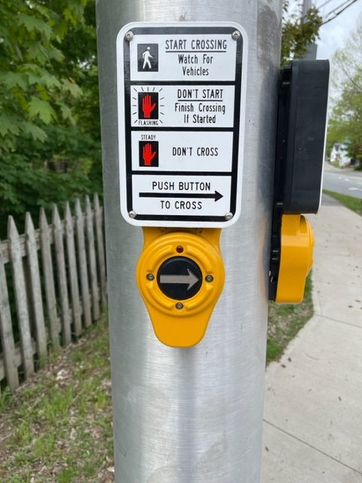

Accompanying Text: I’ve heard people complain about the sounds these crossing buttons make. Because I have sight loss, those sounds are how I know when it is safe to cross the street, meaning I can safely and independently move around my community instead of depending on other people or staying home.
ID: An Accessible Pedestrian Signal button with an arrow pointing to the right and mounted on a metal pole at a street crossing. The sign above it describes how to interpret the pedestrian signal lights so people know when to safely cross the street.
Alt Text: Accessible Pedestrian Signal button and accompanying signage at an intersection.

